

Bearware Export
Design Document

Revision History
Date | Version | Description | Author
05/24/06 | 1.0 | Created | Jim Heary
03/17/08 | 1.1 | Updated | Jim Heary

Table of Contents
Overview 3
Business Context 3
Key Abstractions 4
Object States 4
Application Design 5
Overview 5
Design Model 5
Export Format 5
Export Fields 5
Export File- Sample 5
Deployment 6
Overview 6
Deployment Model 6
Runtime Configuration 7
Configuration File (app.config) 7
Database Configuration Table 7
File Structure 7

Overview
The Bearware Export application (BearwareExport.exe) allows Argix terminals to export carton information from directly sorted freight into a file that can be imported into the Bearware System. From this information, [Bearware] clients can generate OS&D and POD information from original vendor BOL/manifest paperwork. The Bearware Export application fulfills the requirements of the business process activity Export Sorted Items shown below.

Business Context

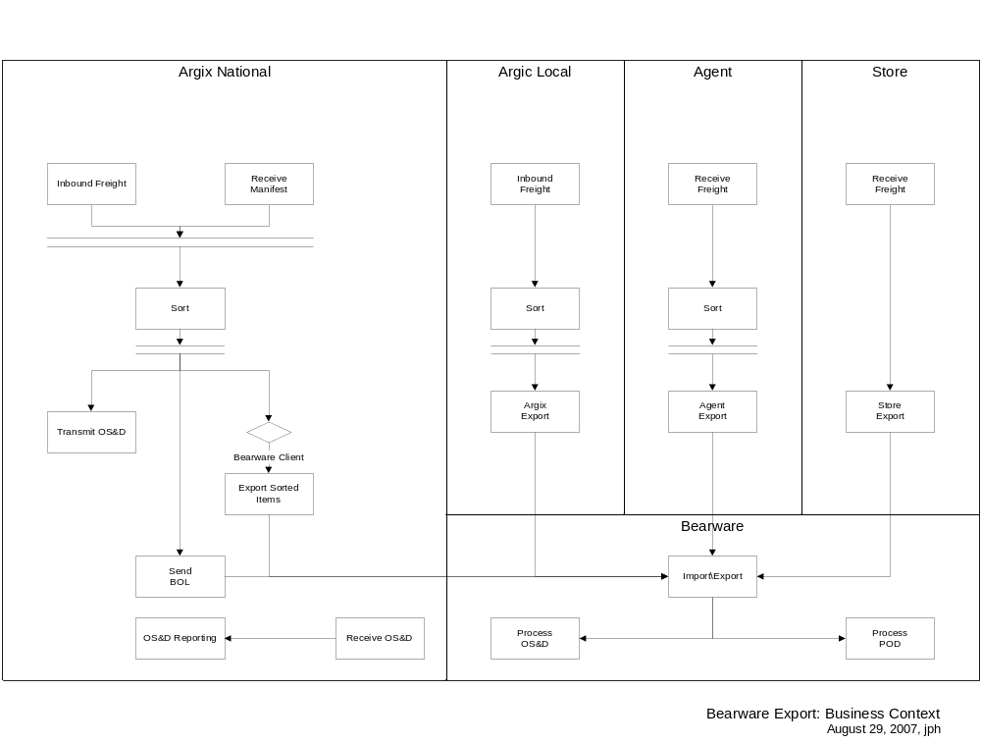

Key Abstractions

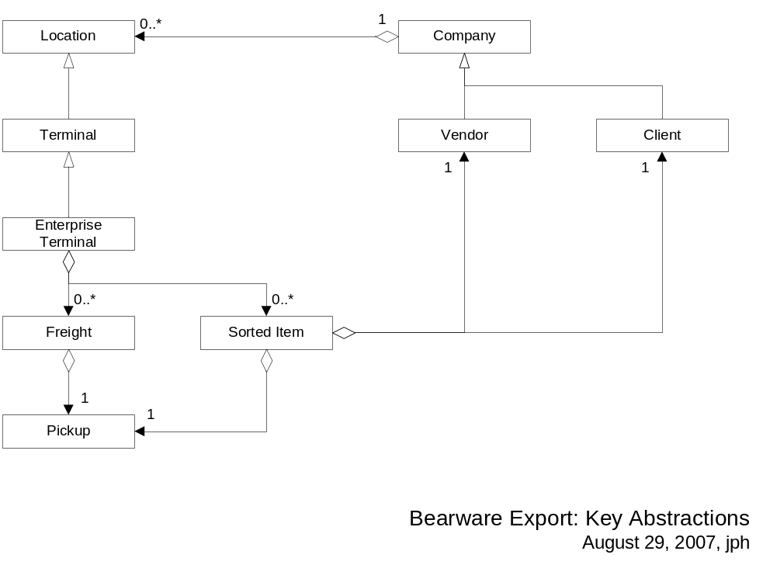

Object States
N/A

Application Design

Overview

Design Model

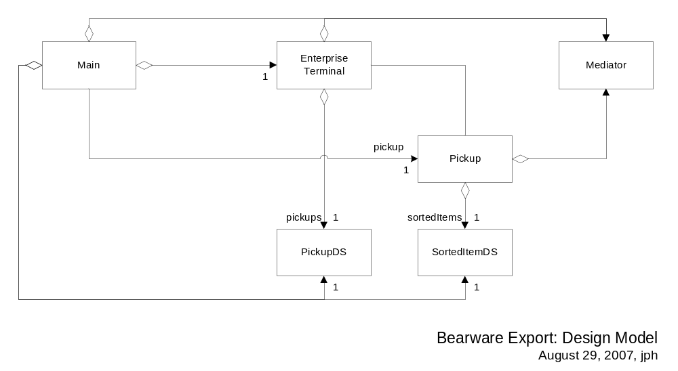

Deployment

Overview
The Bearware Export application creates an export file that is imported into the Bearware System.

Deployment Model

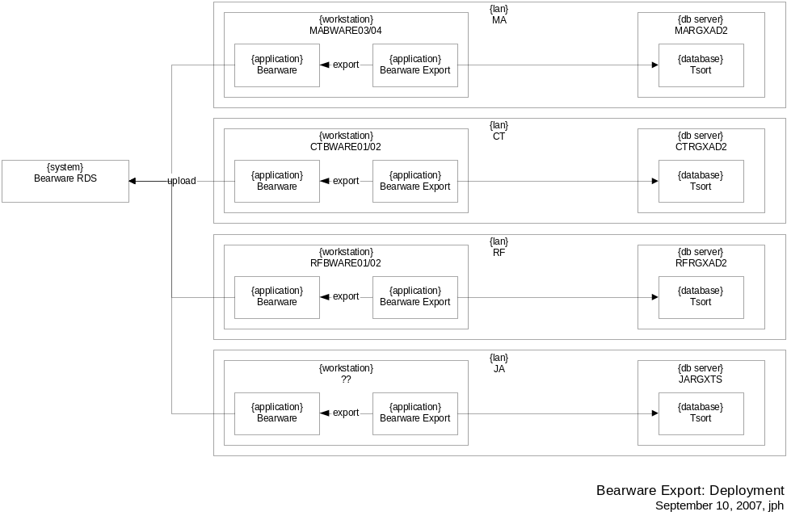

Runtime Configuration
The runtime configurable application parameters are set in the application configuration file and in the Configuration table in the applications database. The following two sections show the run-time configuration required to test the application.

Configuration File (app.config)
Open the application configuration file (i.e. BearwareExport.exe.config), go to the <configuration> section, and add/edit the values below:
<configuration>
<!-- Test configuration -->
<configSections>
<sectionGroup name="menu">
<section name="help" type="System.Configuration.NameValueSectionHandler" />
</sectionGroup>
</configSections>
<menu>
<help>
<add key="Contents..." value=" htm" />
<add key="Release Notes..." value=" " />
<add key="Issue Log..." value=" " />
</help>
</menu>
<appSettings>
<!-- Client configuration -->
<add key="UseWebSvc" value="false" />
<add key="EventLogMachineName" value="RGXDEV" />

<!-- Tsort.Data configuration -->
<add key="Tsort.Data.DataWS.DataAccess" value="http://RGXDEV/RGXDEVDB.TSORTLOCAL.WebSvc/DataAccess.asmx" />
<add key="SQLConnection" value="data source=RGXDEVDB;initial catalog=TSORTLOCAL;persist security info=False;user id=*;password=*;packet size=4096;Connect Timeout=30" />
</appSettings>
</configuration>

Database Configuration Table
Open the local sort database (i.e. TSORTLOCAL on RGXDEVDB), goto the Configuration table, and add/edit the values below:
Application PCName Key Value Security
--------------- --------------- ------------------------- ------------------------- --------
Bearware Export Default DateDaysBack 60 1
Bearware Export Default MISPassword ******** 1
Bearware Export Default TraceLevel 3 1

File Structure
Bearware Export is installed into a deployment folder visible from an IIS web server as follows:
1. Create a virtual folder c:\inetpub\wwwroot\IndirectSort on a web server like RGXDEVDB using Windows Explorer.
2. Copy the following files into this folder:
BearwareExport.exe
BearwareExport.exe.config
Infragistics.Shared.v6.3.dll
Infragistics.Win.UltraWinGrid.v6.3.dll
Infragistics.Win.v6.3.dll
Microsoft.ApplicationBlocks.Data.dll
releasenotes.txt
Tsort.AppLogging.dll
Tsort.Controls.dll
Tsort.Shared.User.dll
3. Launch the Internet Information Services snap-in and validate that the virtual folder allows anonymous access. A web application does not need to be created for deployment.

Appendix: RDS Export Format

Export Files
Client File
filename = #########0.txt
contents = 1 Trailer record, 0+ Sorted Item records
Argix File
filename = #########0.txt
contents = 1 Trailer record, 0+ Sorted Item records

Trailer Record
TPAYLES06JSBM00381786527 109873 DIGYI
TBLOCKBPPSODM0078233684A69A 0030108 BILTI
-======--===--------========--------====-
|| | | | | | | |
ab c d e f g h i

a) Record Type [Required; 1]
- Constant "T"
b) Company Code (See Company Code Table) [Max Length 6]
- ANNTAY = Ann Taylor; LTA = Argix
c) Scanner Number [Required; 2]
– Blank
d) Scanner UserID [Required; 3]
– Blank
e) Trip Number [Required; 8]
– Client file = sorted item vendorKey (first 8 positions)
- Argix file = sorted item TDSID (last 8 positions)
f) Trailer Number [8]
– Trailer# or blank
g) Seal Number [8]
– Seal# or blank
h) Carrier SCAC Code [4]
– Blank
i) Scanner File Type [Required; 1]
- I = Inbound Scan

Sort Record
S29127133277 020021220094806123456
S000744232835 020040809084200
S1850200205252 020040809102100
S060440839041028135854050 020041102084439
S0000420018049386522806125 020061031082012
-==========================-========------======
|| || | |
ab cd e f

a) Barcode Origin [1]
– S = Scanned; M = Manual (always S for RDS Export application)
b) Barcode Stream [26]
- Client file = sorted item vendor item#
- Argix file = sorted item# (build 24 position: client#+44/88+store#+labelseq#+0)
c) Damage Code [1]
- sorted item damage code
d) Scan Date [8, YYYYMMDD]
- sorted item sort date
e) Scan Time [6, HHMMSS]
- sorted item end time
f) Override (Inbound) or From Store (Return, Transfer) [6]
– Blank

